Zachery Francis
CISC 3140
2/24/2026
Brooklyn College

Homework 2

Creating the Repository and Adding a File
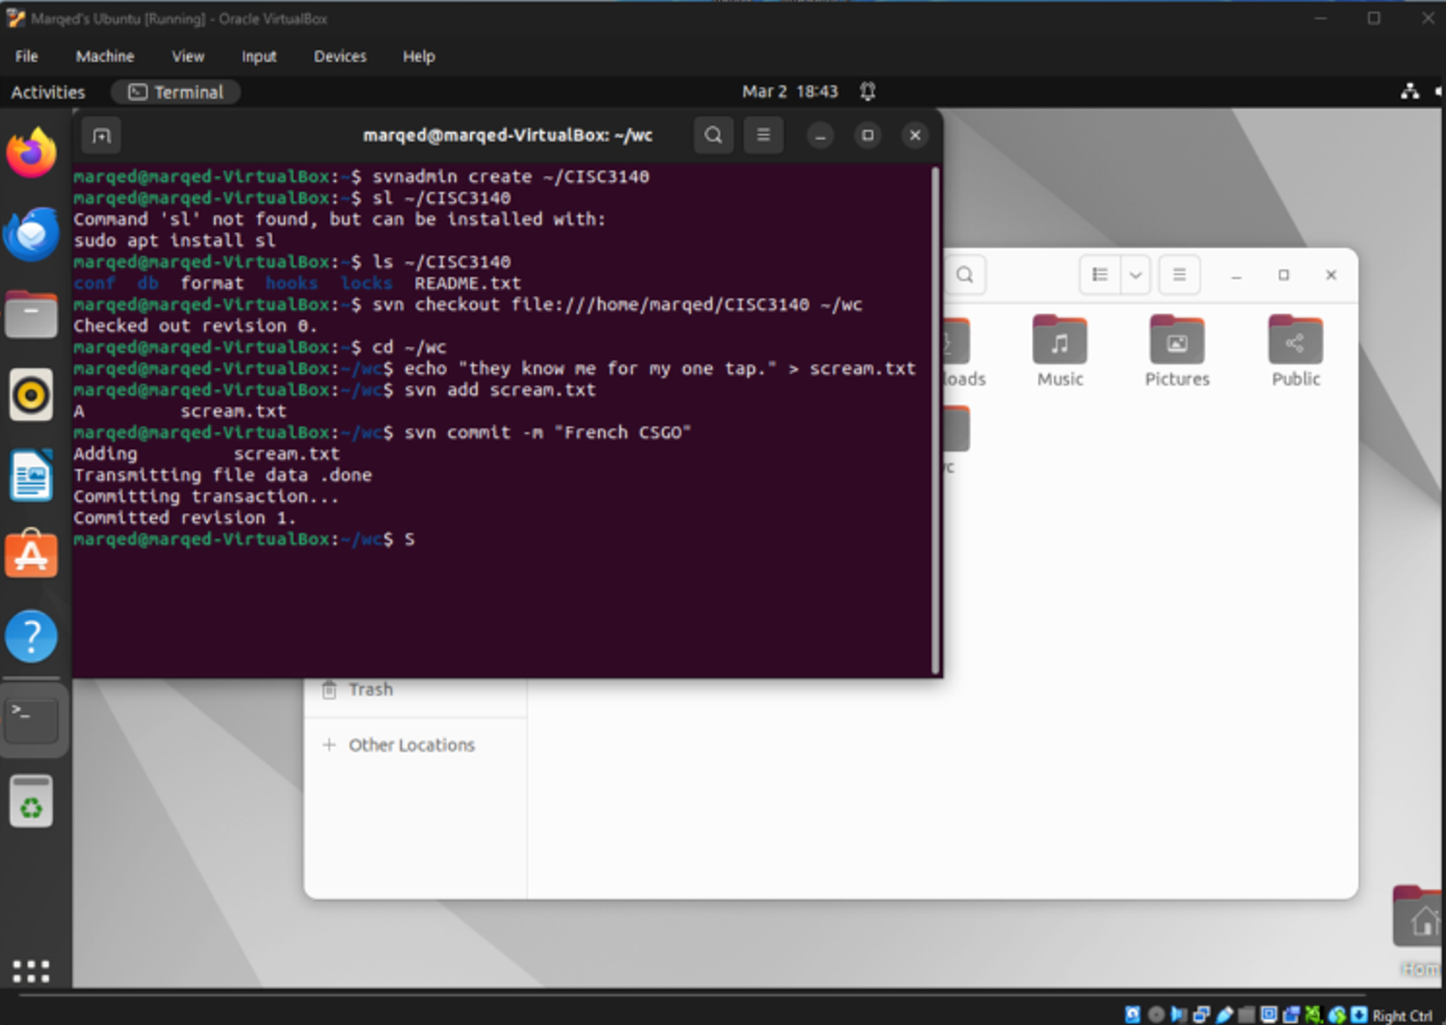
Inspecting the Text File

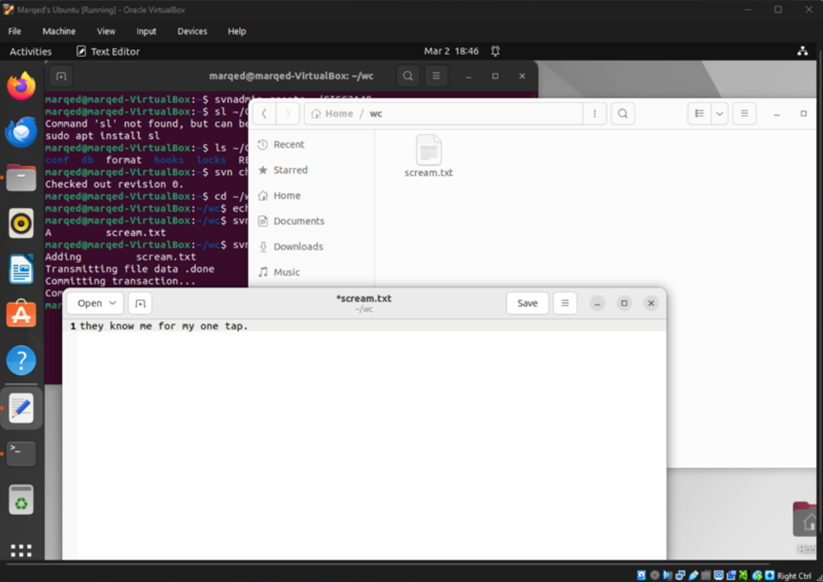

Deleting the Text File
